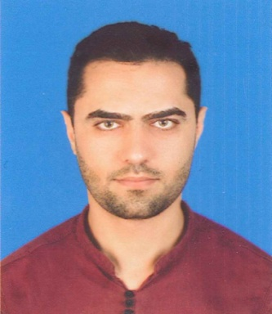
Mahmoud Faiz Kraizim
Mobile : 0599330509
E-mail: mahmoud88k@hotmail.com
Home: Al-Zahra 15/102 ,Gaza ,Palestine
PERSONAL DATA

Date of Birth: 20/09/1988
Gender : Male
Nationality: Palestinian
ID NO. : 410144778
lANGUAGE

Arabic Language Score : (Native LANG).

English Language Score : nearly 7.0 (Listening, Reading, Speaking, and Writing).
EDUCATION

2005 High Secondary School –Al-Karmel Secondary School .
2015-2017 Diploma** Business Administration from Al-Azhar University Gaza (Score 94.7% ) .

EMPLOYMENT

2017/10-2018/06 Clerk at UNRWA .
2018/07-2019/02 Administrative Assistant at Al-Hamd Pharmacy .

2019/03-2019/05 Data Entry at Palestinian Kuwaiti for Social Welfare .
2019/11-2020/08 Data Entry at M.O.H .

2020/02-2020/03 Data Entry at Al-Rahma for Relief and Development .

Skills

• Collects data and other information relating to the activities of the administrative services division and examining its correctness as required;
• Prepares, verifies, maintains and updates records in prescribed formats for use by the unit’s staff;
• Maintains the general files and various registers as required such as inventory listings, personnel records of the unit’s staff, job files and correspondences exchanged with other departments/divisions/sections;
• Performs word processing and other computer duties as required;
• Performs such other work as may be assigned.

OTHER Skills

• Efficient using MS. Office(Word , Excel ..) Application & Surfing the internet.
• Ability to Deal with all programs Software & Hardware
• Can type in English & Arabic good.
• Deal with a lot of programs like Photoshop , Internet Programs …etc.
• Speaking , Talking , Typing English good .

