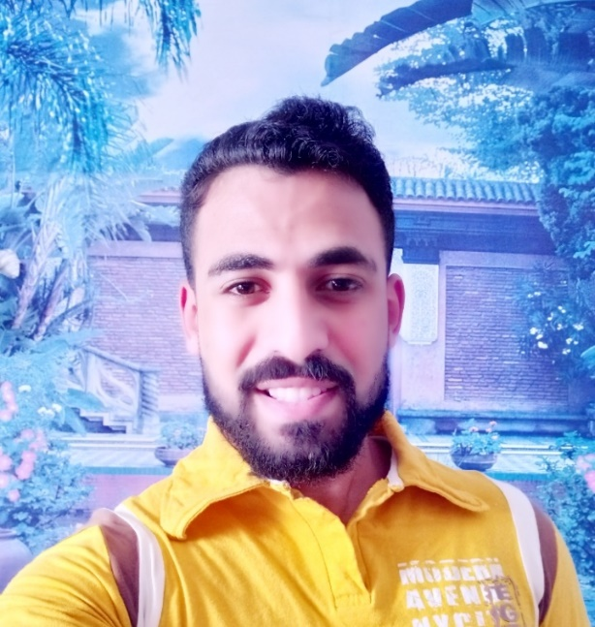
Personal Data
Mohammed Saied Salem Sisalem
Palestinine
Singel
11th Nov 1991

Experience
Jawwal Telecommunications - Dealler & data entry , Gaza 14\12\2010-29\12\2010
The Ministry of Communications and Information Technology - Programmer databases , Gaza 8\6\2011-19\7\2011
Space Design - Designer Graphics , Gaza 5\11\2012-28\2\2013
Education - Elsalam Center - Administrative and public relations , Gaza 1/7/2014-11/5/2015
Royal Paradise Hotel – Shift Leader , Sharm Elshikh – Egypt 1\7\2015-15\12\2015
Ecco Company - Project (Atheeb Union (Saudi Arab) Telecommunications) - customer service , Cairo – Egypt 1\9\2016-22/8/2017
Etisalat Misr Telecommunications (Telesales , Sales Outdoor) Cairo 1\10\2017-10/12/2017

Objectives
Get a good and successful business in place mingled with people and I can help them and meet their demands
Education
Deplom - Programing and databases - Al-Azhar University, Gaza
2009-2011
Contact Information
Address : ElDaraj- ElWehda Street - Masjed Elsayed Hashim – Gaza
Mobill No : 0597736531 – 0599282541
Email : mohammedsaied418@gmail.com

Training Courses
French Course – French Cultural – Delf A1 , Gaza 1\7\2010-15\11\2010
Course In Public Relations – World Press Union , Gaza 20\3\2011-5\4\2011
Course in Human Development – Madar IT , Gaza 1\7\2011-30\7\2011
First Aid – Palestinian Red Crescent , Gaza 30\1\2013-13\2\2013
TV Imaging – Media Monitor , Gaza 15\2\2013-17\3\2013
Cartoon – Turkish Cultural Center , Gaza 24\8\2013-23\9\2013
Leadership and Innovation in Small Enterprises - University College of Applied Sciences , Gaza 25\1\2014- 4\2\2014

Training Courses
AutoCAD Design – Turkish Cultural Center , Gaza 7\5\2014-16\6\2014
Adobe After Effect – Pixel Information Technology Center , Gaza 1\9\2019-15\9\2019
Adobe Photoshop Design – Turkish Cultural Center , Gaza
Experience
Raya Contact Center Project (Etisalat Misr) customer service , Cairo – Egypt 18\12\2017-31/1/2018
Wasla Outsourcing Project (Vodafone Corbret Survey , Vodafone Back Office , cairo – Egypt 3\10\2018-28\12\2018

Languages
Arabic English French
Reading Reading Reading
Writing Writing Writing
Conversation Conversation Conversation

Skills
The ability to work alone or with a team
Ability to work under pressure & Dealing with people
Dealing with computer and the internet
Very good all Microsoft Office program
Design a program photoshop
Design a program photoshop
Designing interfaces for web pages and mobile applications

