Summary  Graphic Designer with 8 years of progressive experience. Creative, detail oriented and hard worker ,Graphic & Web designer. Energetic self-starter and team builder. Navigates high-stress situations and achieves goals on time and under budget. plus 7 years administrating and leadership work as employed and self employed .  Skills  - quick learner  - Reliable and consistent  - Design work  - Team player  - Excellent work ethic  - Multidisciplinary teamwork  - Results-driven  - Schedule management  - Marketing and advertising  - Sales strategy familiarity  - Point Of Sale (POS) competency  - Analyzing data  - Sales team oversight  - Sales metrics tracking  - Automation scripting  - Test implementation  - Manual product sketching  - Photoshop  - Illustrator  - Figma  - Sketchup  - HTML , CSS and python  Additional Information  - volunteer activist and co-founder of Egyptain organization of health and human development ; participate as general secretory the active mostly in health field specially in spread awareness , flied clinic and delver medication for needy people. | MUSTAFA  FEKRY  Experience  02/2023 - Current  Graphic & Web-Designer  fast programming company | Riyadh, Saudi Arabia  - Employed design fundamentals when selecting typography, colour and layout.  - Mastered Adobe Creative Suite and Photoshop Illustrator to support design work and image editing needs.  - Produced consistent designs to translate across all platforms.  - Remained up to date with web design best practices and industry trends.  - Supported marketing team with written content and proofreading.  - Photographed products and uploaded images to build promotional materials and campaigns.  - Worked with in-house web developers, content writers and designers to cultivate market-leading customer experiences.  - Produced digital advertising to showcase products and heighten brand engagement.  01/2019 - 08/2022  Graphic Designer & marketer  FeedBack.Agency  | Damnhour , Egypt  - Designed engaging brochures, banners and signs for printing.  - Mastered Adobe Creative Suite and Photoshop Illustrator to support design work and image editing needs  - Photographed products and uploaded images to build promotional materials and campaigns.  06/2015 - 08/2018  Graphic Designer  Global.Adv | Damnhour . Egypt  - talented, creative, detail oriented and hard worker graphic designer.  - "Design is not a job, it's my passion" that's my attitude. So, we exert great effort to get the best quality.  - Whatever the challenges facing us, Client satisfaction will be the FIRST PRIORITY for me.  - I'm extremely flexible, responsive and can communicate easily to get the target smoothly and perfectly on the time  - ✔ Branding Design  - ✔ Infographics ✔ Flyer  - ✔ Landing Page Design (psd) ✔ Brochure  - ✔ Logo Design ✔ Presentation Design  - ✔ Banner Ad Design ✔ Magazine Design .  Education  2018  Damnhour university | Damnhour  - Bachelor of Commerce: accounting  Languages
  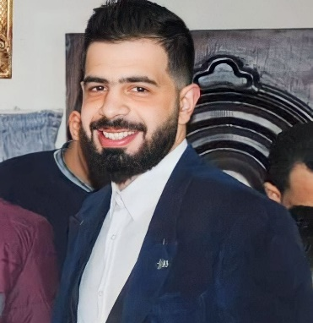.
  - +966 54 638 8110
  - m.apoallo@yahoo.com
   https://gsb6z9tnud33yckvdq544w.on.drv.tw/My%20Website/
  - Riyadh, AL yarmuk 13243
  Arabic: First Language
  English: C1
  Advanced
.

