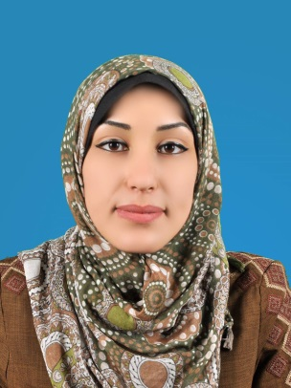
C.V

Personal information:
- Full Name: Noor Al Huda Hani AL-Abd Awwad
- Marital Status: Married
- Sex: Female
- Date of Birth: May19, 1995
- Place of birth: Palestine
- Nationality: Palestinian

Contact information:
- Mobil : 0597467580
- Address : Gaza strip , Middle Area, Al-Zawayda, Abu Bakr AL-seddek st , near to Abu Obida Ben Al –Jarrah Mosque
- Email : noorawwad408@gmail.com
Qualifications:
- University : Islamic University Of Gaza
- Degree : Bachelor and still studying master degree with the second semester
- Specialty :English Business Administration
- Year of graduation : 2018 in bachelor degree

PROFESSIONAL QUALIFICATIONS (TRAINING):
Course | Foundation | Duration (hours) | Finish date
Freelancing (Training) | IUG | 181 | 30/7/2019
Conversation in English Language | Al –Read Educational center | 15 | 9/5/2018
Free lancing | Islamic  University of Gaza | 20 | 14/10/2016
Self -Marketing &Employment Skills | Islamic  University of Gaza | 15 | 3/2/2016
Project coordination | Islamic  University of Gaza | 20 | 2/2/2016
Advanced Microsoft Word | Islamic  University of Gaza | 15 | 10/5/2015
Report Writing | Islamic  University of Gaza | 20 | 22/3/2015

EMPLOYMENT HISTORY:

Position | Foundation | Duration (months) | From | To
Field coordinator | Tawasol forum society | 6 | 20/1/2020 | 3/2/2021
Marketer | Al Hams center | 6 | 25/3/2018 | 2/10/2018
Training experience in Data entry and writing reports | Deir Al Balah municipality | 8 | 10/1/2017  2/6/2017 | 10/4/2017  3/11/2017
experience in the field of lending and development | FATEN | 1.5 | 12/7/2016 | 25/8/2016

Personal skills:

- Full adaptation within the teamwork.
- Ability to perform under pressure.
- Ability to build good social relationships.
- Employ problem-solving skills
- Experience of communications skills.
-Management Skills.
Budget skills.-
Reporting skills.-
Good Monitoring and Evaluation skills.-
-Accountability Skills.
Coordination Skills.-
-Good analytical skills and attention to detail.
Flexible, highly motivated self-starter.-
Fluency in written and spoken English.-

LANGUAGES:
Language | Reading | Writing | Speaking
Arabic | Fluently | Fluently | Fluently
English | Fluently | Fluently | Very Good

REFEREES:
Name | Position | Tel | email
Hadeel Al –Khateeb | Tawasol forum society | +9720592589895 | Hadeeltawasol@gmail.om
Khalil El-Namroty | Department of Economic& Political Science Islamic University of Gaza | +972 8 2860700 | knamroty@iugaza.edu.ps
Fawwaz Abu Maelek | Faten organization | +972 08 9386751 | maelek@1991.org.ps

