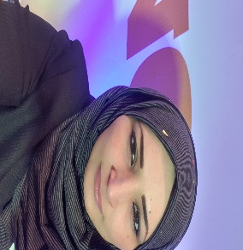
Nour Akram abu sharekh | professional/Sales and Marketing
Aljala Street, Gaza City, Palestine (00970) 599088123

B.A. Marketing Alquds Open University 2017

CAREER SKILLS / KNOWLEDGE

- Advertising Placement  - New Product Pricing  - Product Promotion  - P&L Responsibilities  - Sales Training and Development | - Inside and Direct Sales  - New Client Development  - New Product Case Development  - Competitive Strategy Development  - Long and Short Range Planning

CAREER ACHIEVEMENTS

• Managed the sales department of cosmetic items for the Italian agency Alpha Parf entirely for the Masrouji Pharmaceuticals and General Trading Company, which increased sales by double digits for seven consecutive years.

• Developing strategies for acquiring new customers and expanding market share. Within seven years, the number of active customers increased by 70%.

• Achieving a total market share of 55%, up from 20% in a highly competitive market over seven years.

• The restructuring of Masrouji internal and external sales department. Work with the CEO, managers, and members of the Marketing, Advertising and Sales department .

WORK EXPERIENCE

•Masrouji Company for Pharmaceuticals and General Trading, 2014-present
•Advertising and sales representative: Responsible for developing and implementing marketing plans within my specific sales goal, increasing the market share and increasing the number of new clients.
•Total sales growth is responsible for acting as facilitating customer transactions, including advertising, sales and after sales.
•Telemarketing and closing sales.

