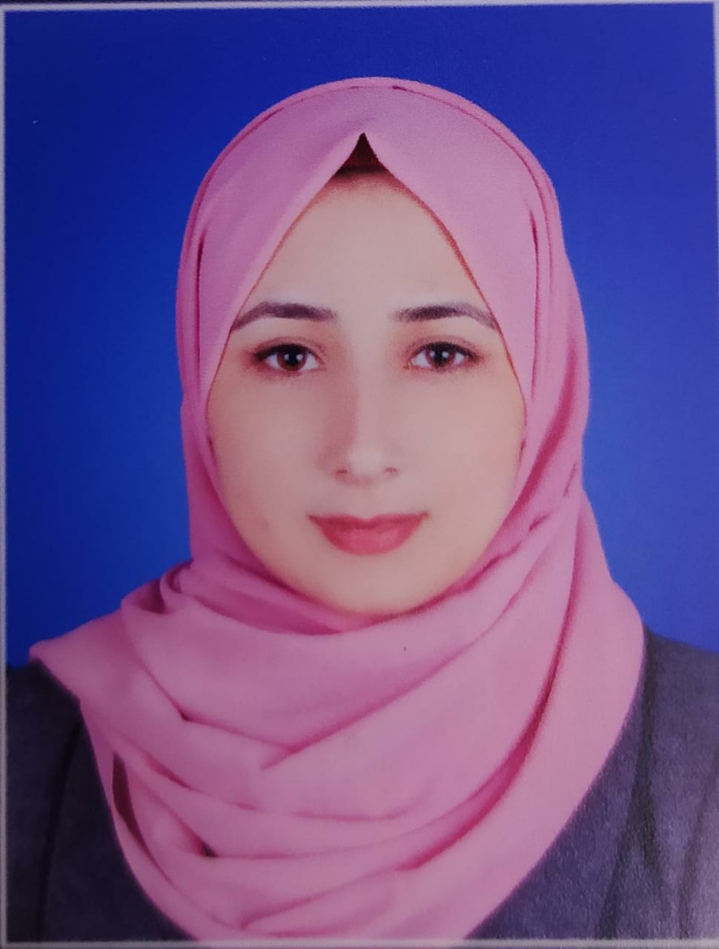 |  |  |  | BESAN SHALADAN
PROFESSIONAL EXPERIENCE
Al –Aqsa University, Gaza, Palestine – 2020
Bachelor’s Degree in English language
Major: Graphic Design and Marketing

Rise Pro, Gaza, Palestine | Aug 2020 – Present
Digital Marketing Manager
• Devise and implement both strategic and tactical digital marketing plans
• Create and implement integrated digital marketing campaigns as planned
• Manage social marketing strategies
• Monitor website metrics to foresee trends and keep tabs on traffic
• Design campaigns to promote products
Content Writing
• The ability to express in writing as well as verbally
• Learn to review and be able to catch mistakes because writing is half of it editing
• the ability to choose the right topic at the right time and write about it in the right way
• Knowing how to write for social media (social networking sites)
Graphic Design
I provide all graphic design services;
Brochure, banner, info graphic, logos, social media advertisement, business card, PowerPoint project etc.
I have been working on Photoshop, illustrator, After Effect, Premier, Power Point and MS Word for a long time and has gained various experiences.
I have also satisfied many Clint. I will try to help you.
 |  | Gaza , 00970
 |  | 00970-59-207-2909
 |  | bisanahmed1998@gmail.com
ADDITIONAL STRENGTHS | • Excellent communication skills  • Ability to work on multiple tasks at one time  • Experience in marketing with e-mails  • Strong analytic and organizational skills

