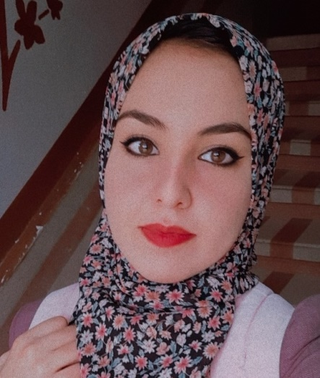  Search Engine Optimization(SEO)  Search Engine Marketing (SEM)  On-Page Optimization  Keywords Optimization  A/B Testing  Google Analytics  Competitive Analysis  Content Development  Google Search Console  Off- Page  Local SEO  Google Tag Manager  Email Marketing  WordPress  Google Ads  Social Media Ads  Front-end web development  HTML  CSS  . |  |  | Ruba M. Alkhaldy  SEO Specialist  A SEO Specialist with three years of experience, specializing in digital marketing, SEM, Social Media Marketing, HTML, keywords optimization, meta descriptions, and Google Analytics.  Adept at collaborating with cross-functional teams and clients to refine content strategy. Practiced in clarifying client requirements, performing analysis between goals and existing procedures, and designing email campaigns, social media initiatives, and websites to increase client revenue.  SEO Specialist  Zoneone • Saudi Arabia• 2019-2021 (Freelancing)  - Perform SEO audits for client website, conduct research on competitors, identify keyword optimization opportunities, and provide recommendations to enhance web page sitemaps, resulting in a 60%-120% increase in organic traffic for customers.  - Oversaw keyword and on-page optimization for the website of the company, which included conducting competitive analysis and identifying SEO strategy.  - Improved Google search rankings by creating alt tags, conducting A/B testing and SEO audits, and performing updates on existing blogs.  .  Marketing and SEO Content Strategist  Grow • Kuwait • 2020 – Now (Freelancing)  - Directed digital marketing, SEO content and email marketing campaigns to promote brand recognition and brand revenue focused activities, and generate leads and sales.  - Provided with Google keyword planning, link building strategy, web analytics and advice in technical SEO. Managed analytics including impressions, clicks, website traffic, views, downloads, leads, etc.  - Managed email marketing campaigns including drip funnel and CRM management.  Bachelor of Engineering: Computer Engineering  IUG,  2019
  CONTACT ME
   | +970-595-134-703
   | alkhaldyruba@gmail.com
   | Gaza, Palestine
   | https://www.linkedin.com/in/ruba-alkhaldy/
  AREAS OF EXPERTISE
  Courses
  WORK EXPERIENCE
  EDUCATION & CREDENTIALS

