+972 59-811-4901
contact: Samah1999mohammed@gmail.com
I have taken a number of courses related to English language and its skills, such as IELTS preparation course , ICDL course ,creative writing and typing course. I have worked in the field of translation since I was a university student, so I have more than 3 years' experience in this field, I have translated a number of files and literary works to or from English.
Language;
- Arabic as native.
- English close to native
graduated from the College of English Literature, from English literature and languages major at 2021.
Islamic University (2017 > 2021)
EDUCATION
Kindness
Hard worker
Responsibility
Excellent at office programs such as (word, Excel)
OBJECTIVES
SKILLS
Samah Shawikh
English translator
It’s me Samah, I have gained a lot of experience as freelance translator, hoping to start a new journey with your company.
I’m organized hard worker to achieve my work not less than art in time.

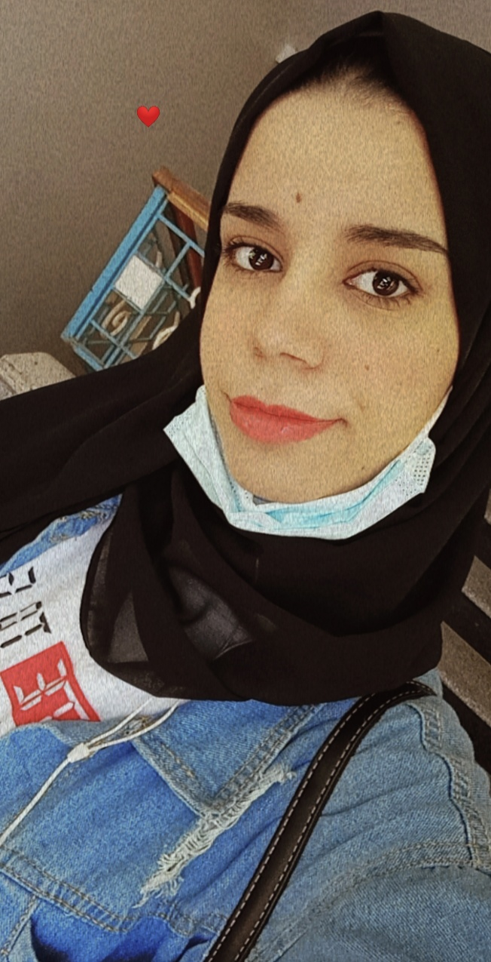
English translator (2019 > Present)
Experiences;

