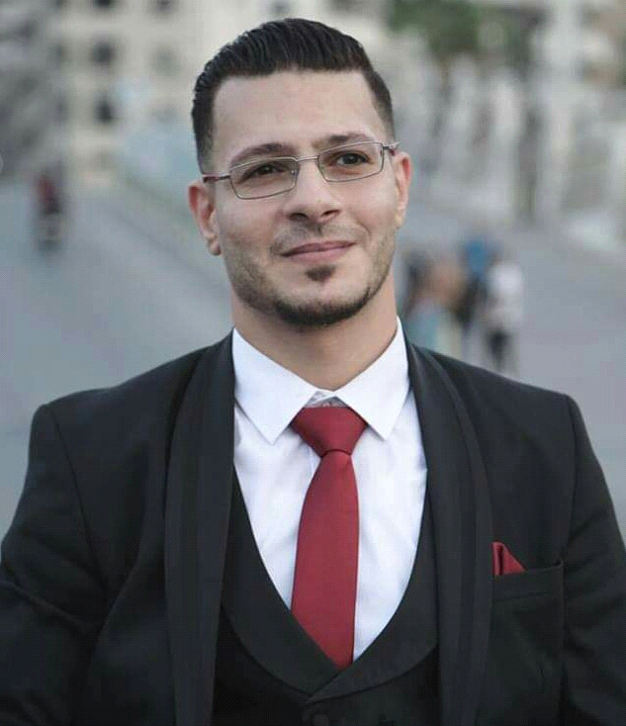

Mahmud M.A. Alatrash
ID
412437204

PASSPORT : 2748856

Address : Tal elhawa area Behind Lighthouse Gaza city

Place of birth: Egypt.

Date of birth: 20.03.1985.

Nationality: Palestinian

Marital status: married.

Jawwal No: 0567/383557

Jawwal No.: 0598/383557

E-mail address: hamada.alatrash@gmail.com

Qualifications

Diploma in journalism and public relations and art's of Al-Azhar University - Gaza
2007/2009

Bachelor in International relations AND PUPLIC Relations and art's from the U.S. World University – Gaza2007/2011

EMPLOYMENT RECORD

mother and child Organization Management and Procurement for Summer Camps. 2007 /2008
U.S. World University Al Nasser St.-Gaza Public Relations Department Journalism and public relations 5/2007 2/2011
Radio OPERATOR FHF DIRECTION PRIVAT CARES ALQUDS Office. Gaza. TWENTY CAR UNDER CALL LOCATION
Director of Facilities Management Services in Jasmine Tower 2017/2018

First Aid emergency

Tender for the mother and child Gaza

Media public relations

enteral Palestinian medical technical adonization

Civil defense evacuation of buildings and to deal with fires

society hope to lide charity Gaza
journalism and public relations
U.S. World University – Gaza
ICDL OFFICE DESKTOPE
E.C.S.P educational​ center success partners
International center for professional trainers
Writing cultural, social and economic development projects related to gender
journalism and public relations
Al WATAN Radio 105.FM
I Learning Driving

I have 7 years of work in associations, centers, news and radio, professional and personal qualifications
Varied experience working with security applications
Familiarity with Microsoft Windows Servers,
Gender and gender courses, writing skills, excellent professional and technical report, strong management, coordination and communication skills, both written and oral
In addition to writing various projects
Ability to work independently with minimal supervision, integrity and honesty in managing financial resources
Proven experience working in partnership with local partners, experience in capacity building, training development and facilitation in project implementation areas
Spirit cooperative and work independently
Proactive and able to take the initiative
Able to manage stress and complexity
Enhance safety and security
Commitment to human determinism
Strong attention to detail
Strong understanding of gender equality and child rights issues
I wish you all the best, success and more programs because the people of Gaza deserve the best health and psychological services

