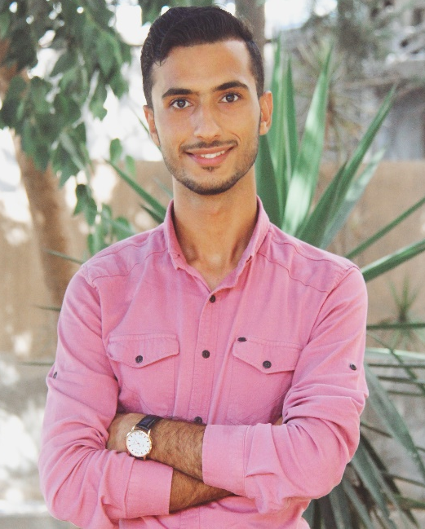

Contact
Address:
Salateen street, Beit Lahya, North Gaza

Phone:
+970598312593

Email:
abedhani20@gmail.com

Facebook:
https://www.facebook.com/profile.php?id=100006355457556

Languages
Arabic – Native
English – Excellent

Certifications
- Certified trainer
- Project management
- Digital marketing
- ICDL
- Taxation consultant
- Proposals writing
- Fundraising

Summary
With several years of experience in project coordination, I bring excellent administrative support to assist project managers in scheduling, budgeting, communication and documentation.

Skill Highlights
- Project management  - Strong decision maker  - problem solver  - Excellent computer user. | - Effective communication  - Service-focused  - Leadership

Experience
Field Marketer - 08/2021 to 09/2021
Islamic University - Gaza
- Cooperate with marketing team to target freshers.
- Explain the job prospects and the educational contents for students willing to join the faculty of economic and administrative sciences college.
- Assist in filling the detailed application for joining the university.
- Demonstrate the nature of the academic life in the university.

Public relations and marketing manager – 02/2017 – 07/2021
Nagham central Library – Gaza
- Setting the annual marketing plan.
- Supervising the distribution panels for stationery, gifts, and accessories.
- Assisting the sales process.
- Contacting customers and vendors.
- Following up the social media platforms.
- Evaluating and measuring the customers' satisfaction.

Education
- Senior business administration at Al Islamic university – Gaza. GPA: %85

Voluntary work
- Ghaith youth team, member in the public relations department.
- Diva youth team, Field assistant.
- Let's rebuild it, operations assistant.
Abdulhamid Hatem
Hemaid

