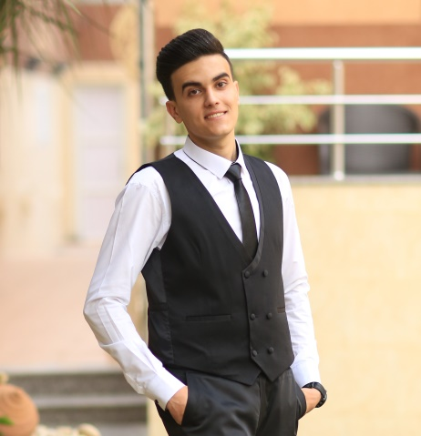
C.V
Personal Details
- Name : Loai Fuad Al-Sosi
- Date of Birth : 10th January 1997
- Marital status : Married
- Address : Al-Moghrabi Street, Al-Sabra, Gaza
- Jawwal no. : 0597744610
- Email : loai-1996@hotmail.com

Education
- High level education: 2014-2016 diploma E-Business in Khan Younis Training College with good average(75%)
- Low level education: 2013-2014 Palestine school.
Works
- 10/2016: director manager and accountant of Dental center.
- 2/2018: PHP Laravel web developer in ATYAF Company for 3 months.
- 12/2018: PHP Laravel web developer in HEXA Company for 5 months.
- 6/2019 PHP Laravel freelancer until now.

Courses
- Typing skills
- Communication Skills
- Marketing and E-Marketing Skills
- 65 training hours ASP.net MVC at Gaza sky geeks.
- 65 training hours PHP LARAVEL at Vision Plus.

Skills
- Using my knowledge of programming, I can develop a program for managing files and archiving electronically.
- Huge Experience in management and accounting.
- Deal with Al-Aseel management and development.
- Familiar with analysis, and making reports.
- Have a driver's license.
- Very good knowing of communications and public relations.
- Have a good enough of Premair, Word, Excel and Power point.

Languages
Language | Reading | Writing | Listening
English | Very good | Very good | Good
Arabic | Excellent | Very good | Excellent

Referees
- Mr. Mohammed Al-Agha, Senior instructors in Khan Younis Training College Phone: 0597920353,

- Eng. Basil Qeshta, trainer of Laravel course 0599624984

