Experience
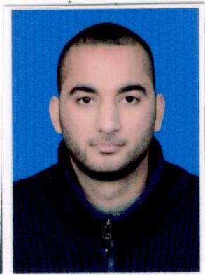

wisam elnajjar
  - deputy director

profile
Deputy Director with over 6 years of experience providing administrative support to over 50 staff members and interfacing with facility management and IT. I possess strong multi-tasking skills, with ability to simultaneously manage several projects and schedules. Excellent public-facing point person for clients, customers, vendors and equipment and service providers. Tech savvy and efficiency focused.

contact
Wesam_a_2007@hotmail.com
00970592716422
Palestina

Activities and Interests
Reading • Preserving the Environment • Listening to Music • Hiking • Fishing • Traveling • Computer Experience
DEPUTY DIRECTOR /Al Aref Company for Tourism and Travel, University Services and Languages
SEP 2009 -Nov2014
Manages schedules, organizes office functions, and oversees daily operations of office with 20 employees. Hires. Interfaces with IT and facilities to situate new employees in their work environment as efficiently and stress-free as possible. My systems have expedited staff assimilation by 20% and reduced office expenses by 15%. Renegotiate vendor contracts, implement office supplies inventory control, and standardize office ordering procedures. Implement cloud-based data management system, utilize CRM to its full potential.

Office Assistant at the Golden Adviser Company for Tourism and Travel, University Services and Languages
September 2014 - July 2020
For the staff of 6, daily, weekly and monthly reports and appointment calendars are prepared for the executives. Performs basic business functions including book settlement. Business calls from European countries, error correction, and inefficiency treatment for 2% office savings in the first six months An average of 40 phone calls per day were answered, examined, and transferred. Developing office operational guidelines for employees and increasing efficiency by 22%.

Education
Nursing Diploma

Community College of Applied Sciences

june 2017”

key skills and characteristics
Strong interpersonal & communication skills • MS Office Suite • WPM: 90 • Ability to work collaboratively as part of a team • Problem Solving • Leadership • Meticulous attention to detail • Excellent Organizational skills • Poised under pressure

