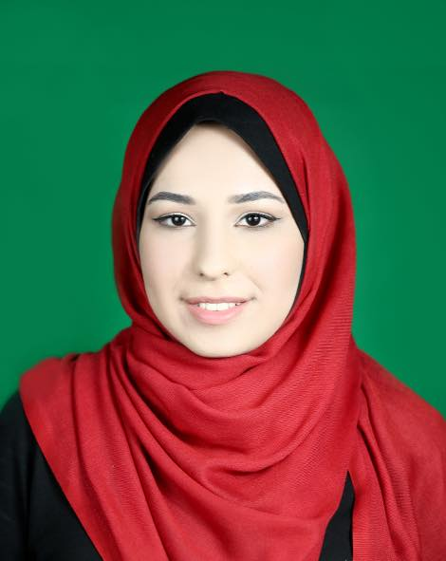 | Rawan Hamad
Contact  PHONE:  0599378581  EMAIL:  Rawanhamad94@hotmail.com  Certificates :  - Professional Project Management Course at SMET-UNRWA with dr. Rajab Al-sarraj (85 hours)  - MS project course  - PBT TOEFL course certificate at AMIDEAST – Gaza | EDUCATION  Islamic University of Gaza  2018 - present  - Master in Business administration at Islamic university of Gaza(MBA)  Islamic University of Gaza  2012 - 2016  - Civil Engineering at Islamic University of Gaza with highly good evaluation .  Basheer Al-Rayyes school  - High school at Basheer Al-Rayyes school with 90.1% percentage .  WORK EXPERIENCE  Hamad Group Company  Dec 2018 –July 2020  - Administrative assistant at Hamad group Company  AlAmeen Company  Sep 2016 – Nov 2018  - Site engineer at Al-Ameen building (1,2) with Al-Ameen company for finance and investments  Training at UNRWA  April 2016 – august 2016  - Training with UNRWA to supervise the construction of two buildings for Al-Azhar university in Al-Moghraga-Gaza  SKILLS  - Good communication, planning and organizational skills.  - Highly developed numeracy and computer literacy skills( word , excel ,PowerPoint )  - Self motivator and the ability to motivate others..  - Able to work on your own initiative as well as being a team player

